
RAJALAKSHMI ENGINEERING COLLEGE
THANDALAM, CHENNAI-602105

CR23532 CYBER AND DIGITAL FORENSICS
CASE STUDY ASSIGNMENT 2

Submitted by
Nandhini Velmurugan
2116241901063

COMPUTER SCIENCE AND ENGINEERING
(CYBER SECURITY)

ACADEMIC YEAR: 2026 - 2027
October 2026
Assignment | Scenario | Units covered
1 | Cloning of a private payments repository from a startup server using a former intern's active credentials | Unit I: Digital forensics process, legal framework
2 | Hidden cryptocurrency-mining program on a family PC with four user profiles | Unit II: Forensics environment, ILookIX
3 | "The Wedding Film Leak": seizure and imaging of a freelance editor's laptop, HDD and SSD | Unit III: Collecting evidence, IXImager, ASB
4 | Recovering altered gold-inventory sheets deleted by a jeweler shop manager (Volume Shadow Copies) | Unit IV: Analyzing evidence
5 | Fraudulent UPI collects requests linked to a shopkeeper's phone and laptop | Unit V: Other sources of evidence

ASSIGNMENT 2(1): UNAUTHORIZED ACCESS TO A SOURCE-CODE REPOSITORY SERVER

TITLE: Cloning of a private payment’s repository from the startup server REPO-SRV01 using a former intern's still-active credentials.

UNDERSTANDING THE CASE
Nimbus Forge hosts its private Git repositories on a self-managed server, REPO-SRV01 (Linux, GitLab-style web interface plus SSH). Arjun M., a development intern, left on 30 June 2026. HR's offboarding checklist was never passed to IT, so his account arjun.m, his SSH key and his VPN profile stayed active. On Saturday 3 October 2026 the security lead noticed an alert: the private repository payments-core (about 1.8 GB, including API keys in old commits) was cloned at 01:10 IST. The server logs show the clone came through the VPN using arjun.m, from the office address of a spare workstation, WS-DEV-12, which was his old desk machine. The workstation was found powered on and logged in the next morning, with a 64 GB USB drive in its port.
The team must preserve the evidence, work out what happened, and avoid assuming the former intern did it, because several people could know or reuse his credentials.
Assumptions
(1) The CTO has given written authority before any seizure.
(2) SSH authentication logging and GitLab audit events were on.
(3) The server clock is NTP-synchronized; the workstation clock is not guaranteed.
(4) WS-DEV-12 was left with autologin and a saved VPN profile.
(5) The intern's company laptop was returned and re-imaged in July, so it is not evidence.

Q1. Forensic phases applied to this case
The investigation follows the standard digital forensics process: Identification, Collection, Examination, Analysis and Presentation. Each phase hands a defined output to the next.
Phase | What the team does in this case | Output
Identification | Verify the alert, record who raised it and when. Define scope (REPO-SRV01, VPN gateway, WS-DEV-12, the USB drive, the account arjun.m). Get written authorization. List likely evidence: GitLab audit and SSH logs, VPN logs, workstation, USB, repository clone metadata, badge and CCTV records, HR offboarding file. | Case file, authorization letter, evidence list
Collection | Secure the office area and photograph WS-DEV-12 as found. Capture volatile data first (logged-in users, running processes, network connections, VPN state). Then create write-protected images of the workstation disk and USB. Export server logs read-only. Hash everything and open the chain-of-custody record. | Forensic images, log exports, hash list, custody forms
Examination | Work on verified copies only. Extract the file list, deleted entries, registry hives, shell and Git history, USB records and server logs. Filter out operating system and known files so that attention stays on relevant data. | Filtered, documented data sets
Analysis | Correlate the artefacts. Build the timeline. Test who could have been at WS-DEV-12 at 01:10 (badge, CCTV, other logins). Check whether the credentials were used from anywhere else, and whether another insider knew the intern's password or key. | Timeline, findings, confidence level for each finding
Presentation | Prepare the forensic report, an executive summary and annexures. Explain the results simply to the founders and HR. Keep the work reproducible so another examiner can repeat it. | Final report, briefing, evidence handed to custody
Q2. Investigation flowchart
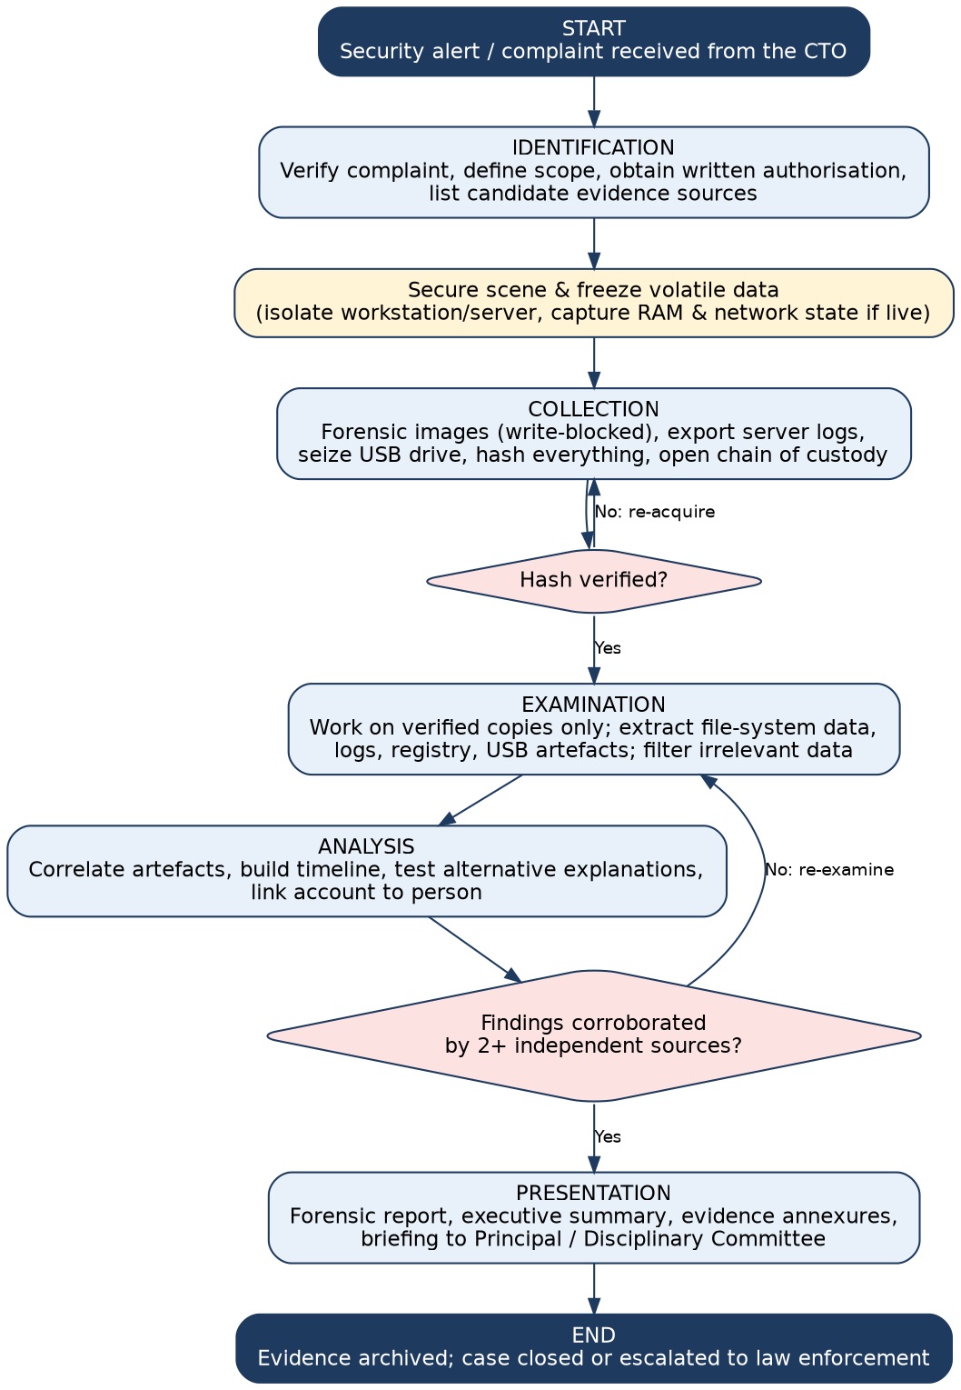
Figure 1: Forensic investigation flowchart, from complaint to presentation of findings
Q3. Potential digital evidence and its investigative value
"Value" shows how strongly each item can answer the questions: what was taken, from where, using which account, and how it left the system.
ID | Evidence item | Source | Type | Value | Why it matters
E1 | GitLab audit events and SSH auth log (clone, token and key events) | REPO-SRV01 | Server log | High | Shows account, key fingerprint, source IP, repository and time of the clone. Core evidence of access.
E2 | VPN gateway log | VPN appliance | Network log | High | Shows when arjun.m connected, from which address, and for how long.
E3 | Workstation disk image (WS-DEV-12) | Internal drive | Storage image | High | May hold the cloned repository, shell and Git history, saved credentials, deleted files.
E4 | USB drive found in WS-DEV-12 | Recovered at scene | Removable media | High | May contain a copy of the repository. Its serial number can be matched to registry USB records.
E5 | Registry USB history (USBSTOR, MountedDevices) | Workstation image | System artefact | High | Shows the drive was connected and when.
E6 | Cloned repository directory and Git metadata (.git objects, reflog) | Workstation / USB | User data | High | Commit hashes prove that the copy matches the server repository; reflog shows the clone time.
E7 | Badge-reader log and CCTV footage | Facility records | Contextual (digital) | Medium | Place a person at the desk at 01:10. Does not show what was copied.
E8 | HR exit records and IT ticket history | HR / IT | Documents | Low | Shows the account should have been disabled, which explains the opening, but is not proof of the act.

Classification. High-value items (E1 to E6) directly show access, transfer or possession. Medium-value items (E7) corroborate who and where. Low-value items (E8) give context. Server logs and the running state of the workstation are the most volatile and are collected first. The disk and the USB drive are persistent but fragile to accidental writes, so they are write-protected.
Q4. Precautions during collection and preservation
- Authority first. Collect only under written authorization and record the scope so unrelated personal data is not examined.
- Do not work on the original. Image the workstation disk and USB through a hardware write-blocker. Never browse the USB on a normal computer: opening it changes access times and might auto-run files.
- Order of volatility. Capture RAM, logged-on users and network connections first (the workstation is powered on), then logs, then disks.
- Integrity. Compute SHA-256 hashes of every image and exported log immediately, and again before analysis. A matching value shows nothing has changed.
- Server logs. Export logs from REPO-SRV01 with a hash, increase log retention, and do not reboot or rotate logs. Record who has administrator rights on the server, since an administrator could alter logs.
- Documentation. Photograph each device and its connections. Keep a notebook with times in IST and the clock offset of the examiner machine.
- Chain of custody. Every handover is signed with date, time, name and reason. Seal evidence in tamper-evident bags and keep it locked.
- Contain the risk without destroying evidence. Disable arjun.m and rotate exposed API keys after the logs are exported, not before. Preserve the account record.
Q5. Establishing the timeline
The timeline is built by merging time-stamped records from independent sources into one table converted to a single zone (IST, UTC+5:30). Each entry notes its source so the reader can judge reliability. The server clock is the reference, and the workstation clock offset is measured against it.
Time (IST), 2–3 Oct 2026 | Event | Source | Reliability
2 Oct 23:52 | Badge reader: door to the development floor opened (card ID of a current employee) | Badge log | Medium (card holder is not necessarily the user)
3 Oct 00:58 | Interactive session starts on WS-DEV-12 (autologin) | Workstation Security log | Medium (clock offset to be checked)
3 Oct 01:03 | USB device (serial ending 7C19) first connected | Registry / setupapi log | High
3 Oct 01:08 | VPN connection established for arjun.m | VPN gateway log | High
3 Oct 01:10 | SSH authentication for arjun.m using key fingerprint ending :9a:f1 | REPO-SRV01 auth log | High
3 Oct 01:10 to 01:24 | Clone of payments-core (1.8 GB) recorded | GitLab audit / access log | High
3 Oct 01:26 | Local folder payments-core created; reflog shows clone completed | Workstation file system /. git | Medium to High
3 Oct 01:41 | Folder compressed to payments-core.zip and copied to E:\ (USB) | LNK files, USB volume timestamps | Medium
3 Oct 01:52 | Local clone deleted; Recycle Bin emptied at 01:53 | $I record / MFT | Medium
3 Oct 02:05 | USB unmounted; VPN disconnected | Registry, VPN log | Medium to High

Investigators check consistency. For example, the server clone must start before the local folder exists. Contradictions (such as a badge swipe by someone with no link to the account) are reported openly as open questions.
Q6. Final forensic report and presentation to a non-technical authority

Sample report structure
Section | Content
1. Cover and control | Case number, title, examiner name, date, version, confidentiality marking.
2. Executive summary | Half-page plain-language summary: what happened, confidence, recommended actions.
3. Scope and authority | Authorization, questions asked, items examined, items excluded.
4. Evidence list | Items with ID, description, serial number, hash values, source and custody reference.
5. Methodology | Tools and versions, write-blocking, hashing and verification, time-zone convention.
6. Findings | Each finding with its supporting artefact, location and confidence level.
7. Timeline | Consolidated table and figure.
8. Limitations and alternatives | Credential reuse, clock offsets, unrecovered data, other explanations considered.
9. Conclusion | Facts established, facts not established. No opinion on guilt, which belongs to management or the court.
10. Annexures | Hash logs, screenshots, custody forms, glossary, examiner declaration.

Presenting to non-technical people. Start with the conclusion in two or three sentences, then show a one-page timeline. Use analogies (an SSH key is like a duplicate office key that was never taken back). Define jargon in a glossary. Separate "what the evidence shows" from "what we infer", and state confidence and limits clearly, for example "the account was used, but the logs cannot say whether the former intern or someone else was at the keyboard". Recommend practical steps: an offboarding process, key rotation and multi-factor authentication.
Q7. Legal and ethical considerations in a company environment
- Authorization and policy. The employment and acceptable-use policy should allow monitoring of company systems. Authority must come from the CTO or management, and unrelated personal data of staff should not be examined.
- Indian law (confirm with legal counsel). Unauthorized access and data theft can fall under the Information Technology Act, 2000 (for example Sections 43, 66 and 66C for use of another's credentials). Electronic records are admissible with the certificate required under Section 63 of the Bharatiya Sakshya Adhiniyam, 2023, which replaced Section 65B of the Evidence Act. The Digital Personal Data Protection Act 2023 affects how personal data in the repository and in staff devices is handled. Source code and API keys may also be protected as trade secrets and confidential information.
- Privacy and proportionality. Examine only what is needed. A personal USB or personal email found on the workstation should not be browsed beyond the scope.
- Impartiality. The examiner must have no conflict of interest and must report facts that help the suspect as well as those that harm him.
- Confidentiality of evidence. The repository copy contains secrets. Evidence images must be encrypted and access-controlled, and exposed keys rotated.
- Due process and reporting. Give the former intern a chance to respond. If the matter goes to the police, evidence should be preserved in a form acceptable to law enforcement, and customer-data or regulator reporting duties should be checked.
Standards followed: the evidence-handling principles of ISO/IEC 27037 and the international legal framework in the syllabus, such as the Budapest Convention on Cybercrime, which stresses preservation of data and cross-border cooperation.

Summary of deliverables
Investigation flowchart (Figure 1)
evidence table (Q3)
timeline (Q5)
case analysis (Q1, Q4, Q7)
sample forensic report structure (Q6).

ASSIGNMENT 2(2): LINKING A SUSPICIOUS FILE TO A USER
Selected unique scenario
TITLE: Attribution of a hidden cryptocurrency-mining program on a family desktop with four user profiles.

UNDERSTANDING THE CASE
The family's Windows 10 desktop has four profiles: suresh (father, administrator), lakshmi (mother), karthi (son, 19, gamer) and divya (daughter, 16). In September 2026 the electricity bill rose sharply, the PC fan ran at night and the graphics card was hot. A technician found an unfamiliar program, ntsvc_helper.exe, in a hidden system folder, with a scheduled task that starts it at logon, a hidden configuration file, an encrypted archive and a wallet file. Suresh wants to know which profile installed it, and whether it was deliberate or came in with other software. The examiner documents the system, analyses file-system evidence and uses ILookIX on a verified image. As the assignment note says, ILookIX steps describe the intended workflow and are not claimed as executed results.
Assumptions. Windows 10, NTFS, a 1 TB disk with EFI, system and data partitions, and a forensic image already made with a write-blocker and verified by hash. Logon auditing was on. The BIOS clock was 3 minutes fast at seizure. All four accounts have passwords, and the password for suresh is known to the whole family.
Q8. Hardware and software components to document
Category | Items recorded | Reason
Hardware | Make, model, serial number; CPU, RAM; GPU model (important for mining); BIOS/UEFI version and clock; disk make, model and serial; peripherals; network adapter MAC address | Identifies the machine and shows which components were used by the miner
Storage layout | Partition table (GPT/MBR), sizes, file systems, encryption status (BitLocker/EFS), unallocated space | Shows where data may be and what may be unreadable
Operating system | Windows edition and build, install date, last shutdown, registered owner, time zone, patch level, power plan | Defines which artefacts exist and how to read them
User accounts | Names, SIDs, profile folders, last logon, password policy, group membership (administrator or standard) | Basis for linking activity to a profile
Installed software | Browsers, game launchers, game mods and cracks, archivers, remote tools, antivirus and its history, wallet or exchange apps | Shows how the miner could have arrived
Persistence | Scheduled tasks, services, Run keys, startup folders, WMI subscriptions | Shows how the program starts without the user
Network | IP configuration, router, DNS cache, connection history to mining pools | Shows where the miner reports
Examiner environment | Forensic workstation, ILookIX version, hash tool, time offset | Needed for repeatability
Q9. How storage, operating system, file system and metadata help
- Storage devices. The partition layout shows hidden or unlabelled partitions and unallocated areas where deleted data may remain. Serial numbers tie the image to the physical disk.
- Operating system. Windows keeps user profiles (C:\Users\name), registry hives (NTUSER.DAT for each user), event logs, Prefetch, Jump Lists and Recent items. These record what each user ran and opened.
- File system (NTFS). The Master File Table stores file name, size, attributes, parent folder, owner SID and timestamps. Deleted files often keep MFT entries. Alternate data streams and the $UsnJrnl journal can reveal renamed or removed files.
- Metadata. Created, modified, accessed and MFT-changed times give a sequence. Executable metadata (compile time, product name, signature) helps judge origin. File signatures show whether an extension matches real content, for example a ".dll" that is really an executable.
The examiner starts from the miner and works outwards: which folder, who owns it, which profile ran it, when, and where it came from.
Q10. Hidden and encrypted files: effect and handling
Issue | Effect on the investigation | Appropriate handling
Hidden/system attribute (for example C:\ProgramData\Microsoft\Crypto\Update\ntsvc_helper.exe) | Not visible in the normal Explorer view, so a casual search misses it. Can also be a normal system file. | Use a forensic tool that lists all files regardless of attributes. Record attributes and times unchanged. Do not infer intent from the attribute alone.
Misleading names | A name close to a Windows service hides the real purpose. | Check path, signature, hash and publisher; compare with known-file hash sets.
Encrypted archive (AES) and wallet file | Content may show payout addresses, but cannot be read without a password. | Hash and record metadata. Look for passwords or keys only under authorisation. Brute force only if authorised and proportionate.
EFS or BitLocker | Encrypted data may be unreadable once the machine is powered off. | If live, capture keys first; otherwise use recovery keys held in the Microsoft account under authority.
Hidden config file | May contain pool address and wallet identifier. | Record content with hash; treat the wallet ID as a lead for a lawful request.

General rule: do not change evidence in order to read it. Work on the image, keep hashes, and state in the report which items could not be examined and why.
Q11. Evidence-linkage table
Each row is one hypothetical artefact and how it helps tie the activity to a profile. None is conclusive alone.
Artefact | Hypothetical value | Source | What it suggests | Strength
File name and path | C:\ProgramData\Microsoft\Crypto\Update\ntsvc_helper.exe | MFT | ProgramData is shared by all accounts, so the path does not point to one user | Weak
Owner SID | Owner is the administrators group; created by process run as suresh (SID ending -1001) | NTFS security descriptor, event log | Installed with administrator rights. Suresh's account was used, but it is shared knowledge | Medium
Timestamps | Created 12-Sep 22:41; first run 22:43; scheduled task created 22:44 | MFT, Prefetch, Task Scheduler log | Created, run and made persistent within three minutes | Medium
Browser download record | "Texture pack and FPS booster.zip" downloaded from a forum into karthi's Downloads at 22:36; contains setup that drops the miner | Chrome history (downloads) in karthi's profile | Source and profile of the download | Strong
UserAssist / RecentDocs | Setup file run count 1 in karthi's NTUSER.DAT at 22:40 | Registry | Execution under karthi's profile | Strong
Logon events | karthi logged on 22:15 to 23:50; suresh logged on 22:41 (UAC elevation prompt) | Security log (4624, 4672) | Two accounts active; an elevation prompt used suresh's credentials | Medium
LNK / Jump List | Link to the encrypted archive in karthi's Recent folder | Profile folder | That account opened the archive location | Medium
Hidden file | config.json created 22:42 with a mining-pool address and a wallet ID | File content | Configuration for the miner; wallet ID is a lead | Contextual
Keystroke/physical presence | None found | N/A | Nothing identifies who was at the keyboard | Gap
Q12. ILookIX workflow
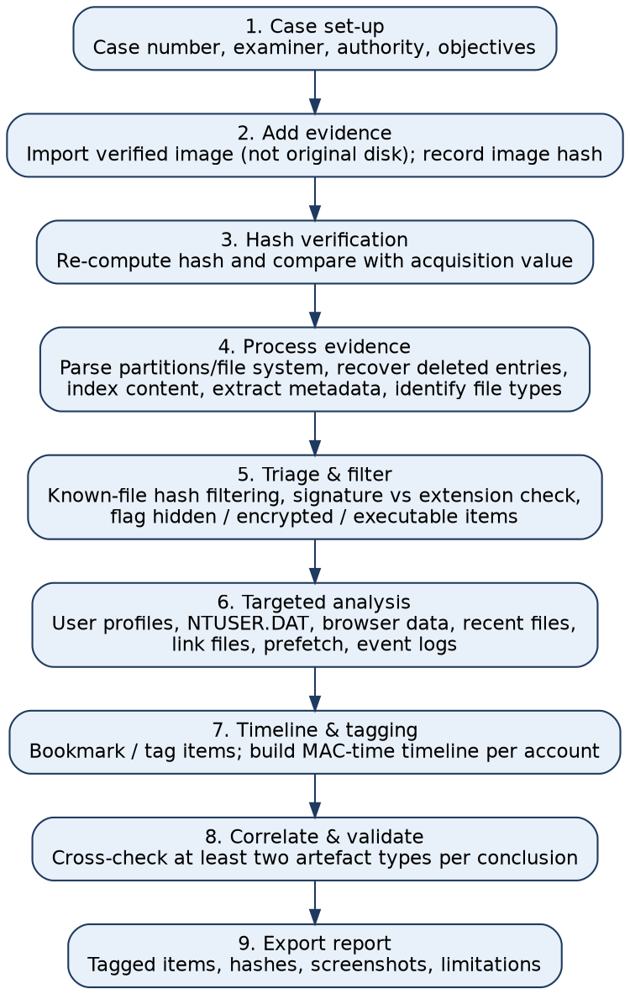
Figure 2: Workflow for importing and analysing evidence with ILookIX (intended procedure)

Key points. The case is created with examiner name and authority. The verified image is added as an evidence item and its hash re-computed. ILookIX then processes the image: it reads partitions and NTFS, lists active and deleted files, extracts metadata and indexes text for fast search. Filters (known-file hash sets, file-type and date filters) remove noise. The examiner tags relevant items, reviews user profile artefacts, builds a time-ordered view and exports a report with hash values and screenshots. Menu names vary by version, so the report should cite the version used.
Expected evidence and interpretation. A file listing for ntsvc_helper.exe with owner and times; registry values showing which profile ran the installer; browser data showing where it came from; and a report of tagged items. A conclusion is drawn only when at least two artefact types agree.
Q13. Direct-link artefacts versus supporting artefacts
Direct link (ties a profile to the act) | Supporting / contextual (sets the scene)
Download record for the "FPS booster" file in karthi's Chrome profile | The miner exists in a shared ProgramData folder
UserAssist or Prefetch entry showing the installer run from karthi's profile | Hidden attribute on config.json
Registry key with karthi's SID showing the installer was opened | A scheduled task with a generic name
User-specific Jump List entry for the archive | Installed game software and mods
Wallet or exchange login in a browser profile | Logon event alone (account active, not necessarily the actor)

A direct artefact is written by the system because of something done under that profile. A supporting artefact fits the story but can exist for many reasons. Each finding in the report is labelled accordingly.
Q14. Limitations and alternative explanations
- Shared password. Everyone knows the administrator password, so the elevation prompt under suresh proves the account, not the person.
- Bundled malware, not deliberate mining. The download came from a game forum. The user may not have known that the package installed a miner, so presence of the file is not proof of intent.
- Remote or automated activity. The program may have been updated or controlled remotely, or another user may have launched it. Check services, tasks and network logs.
- Clock and time-zone errors. The BIOS was 3 minutes fast, and times can be changed by users or tools.
- Copy effects. Copying changes created times and owners, so apparent creation may be a copy.
- Encrypted content unexamined. Without the archive content, relevance and ownership are unknown.
- Tool limits. Different tools parse artefacts differently, so cross-verify with a second tool.

Conclusion
The artefacts point to the miner arriving through a download in karthi's profile, with installation using the shared administrator credentials. The evidence does not prove who was at the keyboard, or whether the installation was deliberate. The report should say: "activity consistent with the karthi profile, with installation under the suresh administrator account", list the limitations above, and recommend interviews, separate administrator credentials, removal of the miner and a review of any wallet or payout trace.
Deliverables: system inventory table (Q8); evidence-linkage matrix (Q11); ILookIX workflow (Figure 2); conclusion with limitations (Q14).
ASSIGNMENT 2(3): FORENSIC IMAGING AND SAFEKEEPING OF SUSPECT STORAGE DEVICES
Title: "The Wedding Film Leak": seizure and imaging of a freelance editor's laptop, external HDD and portable SSD after unreleased wedding footage appeared online.
UNDERSTANDING THE CASE
Lumiere Wedding Films signed an exclusivity contract with a prominent family for the wedding held on 12 September 2026, with the official highlight film due on 25 October. On 2 October, 40 seconds of unedited ceremony footage appeared on a gossip channel. The raw footage had been given to a freelance editor, Vikram S., who worked from home on a Windows laptop with a 4 TB external HDD (exFAT) and a 1 TB portable SSD. The same footage was also synced to a shared cloud folder open to three other people (assistant editor, photographer and studio manager). With the editor's written consent and the studio's authority, the devices were seized on 4 October. The team must collect them without modification, create physical images with IXImager into the ASB container, prove integrity with hashes, consider carving of deleted clips, handle time problems and keep a chain of custody.
Assumptions. The laptop is found powered off, lid closed. Its SSD may use BitLocker, so the recovery key is requested. The leaked clip is a re-encoded, cropped version, not an identical file. Local time is IST (UTC+5:30), no daylight saving.
Q15. Procedure for safe collection and transport
- Authority and plan. Confirm the written authority and consent. Prepare the kit: write-blockers, NVMe/SATA adapters, anti-static bags, tamper-evident tape, labels, camera, notebook and a Faraday bag.
- Secure and record the scene. Photograph the desk, laptop, HDD, SSD, cables, power adapters and the screen. Note make, model and serial numbers, and the time on the camera against a reference clock.
- Assess the state. If the laptop is ON or sleeping, capture volatile data (RAM, active sessions, cloud-sync client state, BitLocker status) before any shutdown. If OFF, do not turn it on.
- Cut the connections. Disconnect Wi-Fi and the network first so that the cloud folder cannot be remotely wiped or changed from the laptop. Record the sync client state.
- Handle the external drives. Do not open any file. Safely disconnect each drive, then place it in an anti-static bag. The HDD needs padded handling because it has moving parts.
- Label and seal. Assign IDs (LW-L01 laptop, LW-H01 HDD, LW-S01 SSD). Seal each with tamper-evident tape signed across the seal. Keep the power supply and recovery-key printout with the laptop.
- Transport. Use a padded case, away from magnets and heat, with two persons present if possible. Do not leave it in a vehicle.
- Log it. Start the chain-of-custody form at the first handover. Store everything in a locked evidence room with an access register.
Q16. Physical acquisition and why analysis uses an image
Physical acquisition copies the storage device sector by sector, from the first sector to the last, whatever the file system looks like. It captures active files, deleted files, slack space, unallocated space and hidden areas. A logical copy gets only the files the operating system presents, and would miss the deleted raw clips that matter here.
Reasons to analyse an image instead of the original:
- Protection of the original. Even mounting a drive can write to it or change times. Changed evidence can be challenged.
- Repeatability. Another examiner can verify results on a second copy by checking the hash.
- Safety against failure. A 4 TB mechanical drive may be ageing. A single good image avoids repeated reads that could damage it.
- Defensibility. The original stays sealed and the image is the working evidence, so the court can see that nothing was altered.
Q17. Imaging workflow using IXImager
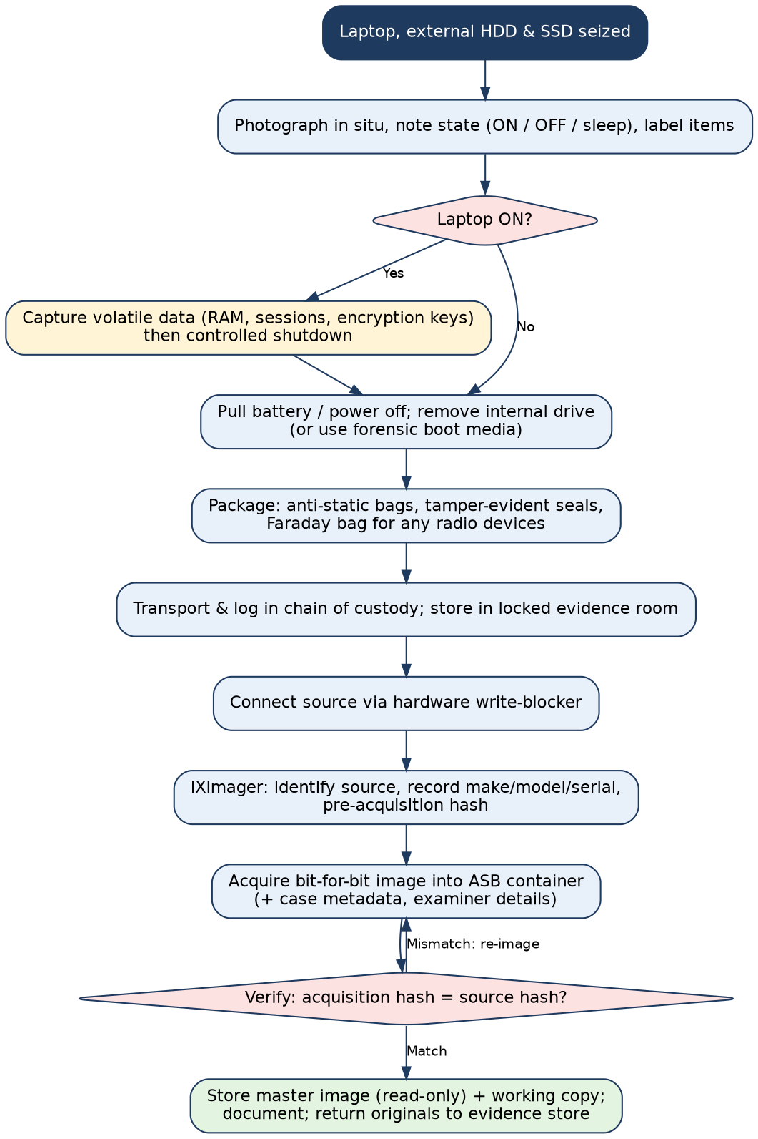
Figure 3: Acquisition flowchart, from seizure to verified image (intended procedure)
Step | Action | What is recorded
1. Source identification | Connect the source and identify it in IXImager: model, serial number, capacity, interface, sector count. Match with labels and photographs. | Device details, evidence ID
2. Write protection | Attach the HDD and SSD through a hardware write-blocker. For the laptop's NVMe drive use an NVMe-capable blocker, or boot a forensic environment that does not mount drives for writing. Confirm the blocker is active and test it. | Blocker make/serial, test result
3. Case data | Enter case number, examiner, evidence number, description and notes in the acquisition dialog. | Metadata stored with the image
4. Imaging | Select the whole physical disk as source and an ASB container as output. Use a clean, large destination drive (about 5 TB for the HDD). Start the acquisition. | Start/end time, errors or bad sectors
5. Hashing | Enable hash calculation while imaging (SHA-256, and MD5 if needed for compatibility). | Source hash value
6. Verification | Run verification after imaging. The image hash must equal the source hash. | Verification result and time
7. Documentation | Export the acquisition log, photograph the screen, sign the form. Make a second copy. Keep the master image read-only. | Acquisition report, copy locations

If BitLocker is on, the physical image contains encrypted data, so the recovery key or a decrypted view is also needed, and how it was obtained is recorded. Menu names and options depend on the IXImager version, so the report states the version used.
Q18. Hash values and integrity
A hash function (such as SHA-256) turns data of any size into a fixed-length value. Changing one bit changes the hash completely, so a hash works like a fingerprint of the data.
Stage | Hash action | Meaning of a match
Before acquisition | Hash the source device behind the write-blocker | Records the original state
After acquisition | Hash the image (or ASB content) | Equal to the source hash: the image is an exact copy
Before analysis | Verify the working copy | Nothing changed during storage or transfer
Before reporting | Re-verify the master image | Evidence is the same as at acquisition

Hashes also compare files. If a raw clip on the HDD has the same hash as the clip in the studio's cloud folder, the content is identical. In this case, however, the leaked clip was cropped and re-encoded, so its file hash will not match any raw file. The examiner must say so openly and use other methods, such as comparing scene content, embedded camera metadata, timecode and frame-level similarity, to link the leak to a source file. SHA-256 is preferred to MD5 or SHA-1 because of collision weaknesses, and using two algorithms is common. A mismatch must be investigated (bad sectors, device fault, handling error) and the image repeated if needed.
Q19. Role of the ASB container
The ASB container is the evidence container used with IXImager and ILookIX. Instead of a plain raw image, it keeps the acquired data together with descriptive information, making the evidence self-describing. Features such as compression and integrity checking depend on the tool version, so the examiner should confirm them in the vendor documentation.
Information that should accompany the evidence:
- Case number, evidence ID, description, examiner, organisation
- Source device make, model, serial number, capacity, interface
- Date, time and time zone of acquisition, and the clock offset
- Tool and version, write-blocker used, acquisition settings
- Source and image hash values and the verification result
- Notes on errors, bad sectors, encryption and recovery-key location
- Chain-of-custody reference and storage location
Keeping this information with the container prevents mix-ups between the three devices and supports authentication in court.
Q20. Data carving
Data carving recovers files from raw data by searching for known signatures (headers and, where possible, footers), without using the file-system directory. Video files from cameras and editors are recognised by their container signatures: an MP4 or MOV file has an "ftyp" marker near the start, and a JPEG starts with FF D8 FF.
When it is needed in this case:
- The editor deleted or formatted clips on the exFAT HDD, so directory entries are marked deleted or gone, but the data may remain in unallocated space.
- The partition table or file system is damaged.
- Only fragments remain in unallocated space.
Limits. Carved files usually lose their name, path and timestamps. Large videos are often fragmented, so carving may give partial or corrupt clips. On an SSD, TRIM and garbage collection can erase deleted data, so the portable SSD may yield little. Carved clips are validated by playing them, comparing with the studio's master list and checking embedded camera metadata.
Q21. Date and time problems
Problem | Explanation | How to document
Time zones | NTFS stores UTC. exFAT stores local time and can include a UTC-offset value, but it may be absent or wrong. Tools may display different zones. | State the zone used in every table; give IST and UTC
Wrong system clock | The laptop clock or the camera clock may be wrong. Camera times in wedding footage may be set by the videographer, and cameras are often left in the wrong zone. | Compare device time with a reference clock at seizure; note offsets for each camera and the laptop
Timestamp resolution | FAT/exFAT use coarse resolution for some fields, and last-access may be a date only. | Note the resolution for each file system
Copy and move effects | Copying creates a new "created" time. Moving within a volume keeps it. | Interpret MACB patterns, not single values
Cloud sync | The sync client may set modified times at upload or download. | Compare local and cloud server times; note the sync history
Tampering | Timestamp-altering tools can set any time. | Compare $STANDARD_INFORMATION with $FILE_NAME times and the $UsnJrnl on NTFS

Every time in the report should have its source, zone and known offset. Where uncertainty exists, give a range, not a single instant.
Q22. Chain-of-custody table (seized laptop)
No. | Date / time (IST) | Item and ID | Released by | Received by | Purpose | Condition / seal
1 | 04-Oct-2026 10:20 | Laptop LW-L01 | V. S. (Editor) | Ms. R. (Lead Examiner) | Seizure at editor's home | Powered off, seal 0611 applied
2 | 04-Oct-2026 10:40 | HDD LW-H01 and SSD LW-S01 | V. S. (Editor) | Ms. R. (Lead Examiner) | Seizure | Anti-static bags, seals 0612, 0613
3 | 04-Oct-2026 13:15 | LW-L01, LW-H01, LW-S01 | Ms. R. | Evidence custodian | Transport to lab and storage | Seals intact, logged in register
4 | 05-Oct-2026 09:30 | LW-L01, LW-H01, LW-S01 | Evidence custodian | Mr. S. (Imaging Examiner) | Forensic imaging | Seals checked and cut; photographed
5 | 06-Oct-2026 18:00 | Originals | Mr. S. | Evidence custodian | Return after imaging; hashes verified | New seals 0620 to 0622
6 | 07-Oct-2026 10:00 | Working copies of images | Evidence custodian | Ms. R. | Laboratory examination | Hash verified before release
7 | 14-Oct-2026 16:00 | Originals | Evidence custodian | Studio's legal counsel | Handover after case review | Seals intact, signed by both

Each row is signed by both parties. A gap or an unsigned row weakens the evidence, so the custodian checks the form at every release.
Deliverables: acquisition flowchart (Figure 3); chain-of-custody form (Q22); imaging procedure (Q17); integrity explanation (Q18).
ASSIGNMENT 2(4): RECOVERY OF DELETED EVIDENCE FROM VOLUME SHADOW COPIES
Title: Recovering altered gold-inventory sheets deleted by a jeweler shop manager after a stock mismatch.
UNDERSTANDING THE CASE
Swarna Mandapam Jewellers keeps its gold stock in an Excel register, Gold_Stock_Register_Sep2026.xlsx, on the shop manager's Windows 10 PC. A physical stock audit on 18 September 2026 found 412.6 g of gold less than the register. The manager, S. Prakash, says the register was always correct. The register on the PC is missing, the Recycle Bin is empty and the browser history is cleared. A forensic image of the PC has been acquired and shows that Volume Shadow Copies exist. The team must select and classify evidence, use Event, Cloud and Lead Analysis, recover earlier versions from the shadow copies, validate them and rebuild the sequence of events.
Assumptions. The image was hash-verified. System Protection was enabled on C: (restore points are created at scheduled intervals and at software or accounting-package updates). The tool is ILookIX or similar, and the steps describe the intended workflow. The weights shown are hypothetical.
Q23. Selecting and categorising evidence before detailed analysis
A disk may hold hundreds of thousands of files. Investigators narrow the data to what answers the case questions: what stock figures existed, who changed them, when they were deleted and whether they left the shop.
- Define questions and keywords. File names, item codes, gold weights (grams), dealer names, date range (1 Aug to 22 Sep 2026), user account.
- Eliminate superfluous files. Filter out operating-system and application files using known-file hash sets, and exclude other users and unrelated dates.
- Locate evidence. Search the manager's profile, Recent items, Office AutoRecover and temp files, Recycle Bin ($I and $R), browser data, registry, billing-software folders, and unallocated space.
- Categorise. Put items into the categories in Q24 and mark priority.
- Document the selection. Record the filters used and what was excluded so the choices can be reviewed.
Q24. Classification scheme
Category | Description | Examples in this case | Priority
A. User-created files | Documents the user made or edited | Gold_Stock_Register_Sep2026.xlsx, sale and purchase sheets, customer ledger | High
B. System / application files | Created automatically by Windows or programs | Prefetch, event logs, registry hives, Excel AutoRecover files, Jump Lists, billing-software logs | Medium
C. Potentially suspicious files | Items whose presence needs explanation | File-cleaning program, history-wiping tool, renamed or hidden copies of the register | High
D. Deleted / recovered artefacts | Items no longer in normal view | Recycle Bin $I records, MFT entries, files found in shadow copies, carved files | High
E. Supporting / contextual evidence | Helps explain but does not prove | Logon records, audit report, WhatsApp messages about the audit, CCTV | Low to Medium
Q25. Event Analysis
Event Analysis builds a chronological view from many time-stamped sources: file-system times, Windows event logs, browser records, registry key times and email or message dates. Placing them on one timeline shows clusters of activity. Here, a burst at 19 September (file deleted, Recycle Bin emptied, browser history cleared, cleaning program run) soon after the audit notice would suggest a deliberate clean-up. It also exposes inconsistencies, such as a file apparently opened when the account was logged off. The result is a hypothesis about the sequence, which has to be tested against other artefacts.
Q26. Cloud Analysis and Lead Analysis
 | Cloud Analysis | Lead Analysis
Purpose | Finds evidence of cloud services used from the PC: sync clients, cached files, account names, webmail and storage activity. | Extracts "leads" from the data: email addresses, names, phone numbers, URLs and accounts, and the links between them, so new lines of inquiry appear.
Questions it helps answer | Was the register uploaded to a personal Google Drive or sent by webmail? Which account was used? Are there copies elsewhere? | Who received the sheets? Which phone numbers or addresses appear repeatedly? Are there unknown accounts or dealers?
Case example | A Google Drive folder holds Gold_Stock_Register_Sep2026.xlsx dated 14 Sep. | A mobile number of a bullion dealer appears in chats and file names, becoming a lead for lawful follow-up.
Caution | Local cache may not equal the cloud contents. A provider request is needed. | Leads are not proof. Each must be verified.
Q27. Volume Shadow Copy analysis
Volume Shadow Copy Service takes point-in-time snapshots of a volume and stores changed blocks, so earlier versions of files can be restored. Because a snapshot freezes the volume at the time of creation, it can hold files that were later deleted or overwritten.
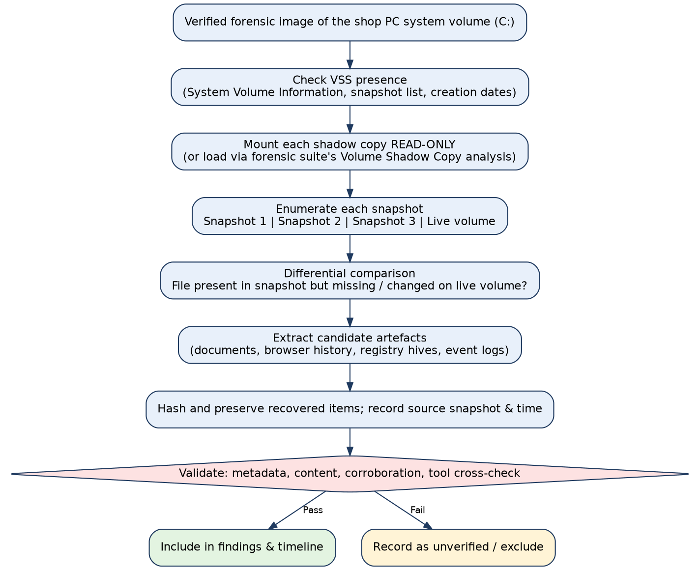
Figure 4: Volume Shadow Copy recovery workflow (intended procedure)
- Recover earlier versions. A register present in snapshot 1 but missing on the live volume was deleted after that snapshot.
- Compare versions. Original and altered registers are compared row by row. Differences in gold weights show what was changed.
- Recover system artefacts. Older browser history, registry hives and event logs that were cleared later may exist in earlier snapshots.
- Work read-only. Snapshots are examined from the image without writing to it, using the shadow-copy view of the forensic tool. Only changed blocks are stored, and Windows can delete old snapshots when space is low, so snapshots may be incomplete.
Q28. Hypothetical timeline
Date / time (IST), 2026 | Event | Evidence source | Note
01-Sep 10:05 | Gold_Stock_Register_Sep2026.xlsx created by manager's account | MFT created time; Excel metadata | Original weights
07-Sep 22:00 | Snapshot S1 created | VSS creation time | S1 contains the ORIGINAL register
14-Sep 15:20 | Register modified: 6 item rows reduced, total reduced by 412.6 g | MFT modified time; AutoRecover file | Altered version
14-Sep 15:48 | Copy of altered register uploaded to a personal Google Drive | Cloud client log | Copy outside the shop's systems
14-Sep 22:00 | Snapshot S2 created | VSS | S2 contains the ALTERED register
18-Sep 11:00 | Physical audit finds a 412.6 g shortfall; owner informs manager | Audit report; WhatsApp message | Trigger for the clean-up
19-Sep 09:12 | Register deleted; Recycle Bin emptied 09:14; browser history cleared 09:16; cleaning program run 09:18 | $I record; MFT; browser database; Prefetch | Deliberate clean-up pattern
21-Sep 22:00 | Snapshot S3 created | VSS | Register absent in S3
24-Sep 10:30 | Forensic image acquired | Acquisition log | Live volume has no register
25-Sep 15:00 | Register recovered from S1 and S2 and compared | Examiner workflow | Differences documented

This shows how a file can be created, modified, copied, deleted and later recovered. S1 and S2 bracket the alteration (7 Sep 22:00 to 14 Sep 22:00), and the 14 Sep 15:20 modified time narrows it further.
Q29. Validating a recovered artefact
Check | Question
Source integrity | Was the image hash verified before and after? Was the snapshot mounted read-only?
Provenance | Which snapshot, path and creation time does it come from, and is this logged?
Content check | Does the file open and show consistent data (item codes, weights, totals)?
Metadata check | Do author, created and modified times agree with the MFT and Excel metadata?
Hash | Is the hash of the recovered file recorded, and the same on a second recovery?
Corroboration | Is it supported by a second artefact (AutoRecover file, cloud copy, email attachment)?
Tool cross-check | Does a second tool give the same result?
Alternative explanations | Could a legitimate edit (for example a recorded sale or melt) explain the changes?
Documentation | Are the steps and settings written so another examiner can repeat them?
Q30. Sources of error and alternative explanations
- Snapshot time is not file time. A snapshot shows the file existed by that time, not when it was created or changed.
- Legitimate changes. Gold weights can change for valid reasons such as sales, melting loss, repairs or returns. Check these against the billing records before calling a change fraud.
- Other users. Another employee with access to the PC or the shared password could have edited the file.
- Automatic changes. Antivirus, indexing or backup software can alter timestamps.
- Clock problems. A wrong system time or time-zone conversions can shift times; compare with logs.
- Partial snapshots. Only changed blocks are stored, so a recovered file may be incomplete or inconsistent.
- Deletion by system or user routine. Cleaners, sync conflicts and storage-sense can delete files, so deletion alone does not prove intent.
- Timestomping and anti-forensics. Wiping or time-altering tools can mislead. Check $UsnJrnl and $FILE_NAME attributes.

Conclusion. If validated, the findings would show that an original and a changed register existed, that the changed one was copied outside the shop, and that a clean-up followed the audit. They would not by themselves show who made the changes or why, so the report separates facts from inference.
Deliverables: evidence classification table (Q24); event timeline (Q28); Volume Shadow Copy recovery workflow (Figure 4); validation checklist (Q29).
ASSIGNMENT 2(5): MULTI-SOURCE INVESTIGATION OF A CYBER INCIDENT
Title: A shopkeeper's phone and laptop linked to a series of fraudulent UPI collect requests.
UNDERSTANDING THE CASE
Between 10 and 12 October 2026, fourteen people received UPI collect requests from the merchant VPA murugan.stores@examplebank, worded as "cashback refund", and several approved them by mistake, losing a total of about Rs. 1.1 lakh. The money moved from the shop's linked account into two other accounts within minutes. The shopkeeper, R. Murugan, says he never sent the requests and that a caller posing as "bank support" had asked him to install a "KYC update" app a few days earlier. Investigators, with consent and proper authority, may examine his Windows laptop (billing software and net banking), browser, email and SMS, messaging records, Android phone, and bank and cloud records. The main question is whether the shopkeeper was the fraudster or the victim of a remote takeover.
Assumptions. Written consent and police authority exist. The laptop and phone are imaged before analysis. Records from banks, payment service providers and telecom operators will be requested lawfully. All times are IST.
Q31. Evidence from Windows and other operating systems
Source | Artefacts | Value in this case
Windows laptop | Event logs (logons, remote-desktop and remote-tool activity), registry (UserAssist, RecentDocs, installed programs), Prefetch, LNK and Jump Lists, Recycle Bin, billing software data, Wi-Fi profiles | Shows whether remote-access software was installed or run, and who was logged in
Browser profile on Windows | History, cookies, downloads, saved passwords, net-banking session data | Shows visits to bank pages, phishing pages and file downloads
Android phone | Installed apps (including side-loaded APK files), app permissions, SMS and call logs, notification history, UPI app data, accessibility-service settings | Shows a remote-control app, the call from the fraudster and any OTP messages
Router / ISP | DHCP logs, IP assignment, connection logs | Links the shop's IP to the activity
Other devices (if any) | A tablet, point-of-sale machine, or a second SIM | To exclude other access paths
Q32. Browser artefacts and why they need careful interpretation
Browsers store the URLs visited with time and visit counts, search terms, downloads, cookies and login sessions, cached pages, form data and saved credentials, and bookmarks. Here they may show: a visit to a look-alike "KYC update" page, a download of a remote-support tool, a net-banking login and a visit to the bank's beneficiary-add page.
Cautions:
- A history entry shows that a page was requested, not that the user read it or typed anything. Redirects, pre-loading and background tabs create entries.
- Browser sync can bring in history from another device, so an entry on the laptop may come from the phone.
- Private mode, cleared history and multiple profiles leave gaps.
- Time stamps use browser-specific formats (for example WebKit time) and must be converted correctly.
- A session cookie shows an active session, not who was at the keyboard, and a remote controller can use the same session.
Q33. Email and messaging evidence and correlation
Type | Evidence | How correlated
Email headers | Sender, Received chain, Message-ID, originating IP, date, SPF/DKIM results | Shows the origin of the phishing "KYC" email and its delivery time; compare with browser visit time
Email body and attachments | Links, forms, file hashes | The link domain matches the page in browser history
Bank and UPI alert emails and SMS | Debit and credit alerts, device-binding SMS, OTP messages, login alerts | Show the time the account was accessed and the sequence of payments
Messaging (chat app) | Messages with the caller, shared APK link, screenshots, call duration, deleted-message traces | Shows who gave instructions and when the app was installed
Call log | Incoming call from an unknown number | Matches the time of the app install and OTP messages

Correlation uses shared identifiers: the same URL, phone number, IP address, device ID, message ID or time window. For example, if the caller's link was opened at 21:12 and a new device appeared in the bank's security alert at 21:30, this supports a takeover.
Q34. Forensic considerations for a mobile phone
- Isolate the phone from networks (airplane mode or a Faraday bag) to stop remote control, wiping and new messages, and keep it powered if it is on.
- Consent and passcode. The PIN or biometric is needed and must be obtained lawfully.
- Acquisition level. Choose logical, file-system or physical extraction depending on device, Android version and encryption. Record the method and tool version.
- Hashing and imaging of the extraction, with chain of custody as for other evidence.
- Data of interest: installed apps and install times, APK files, accessibility and device-admin settings, UPI app data, SMS, calls, location, Wi-Fi history, browser data.
Challenges: strong full-disk encryption; locked bootloaders; frequent OS updates that break tool support; UPI apps that keep little data locally, with most records at the bank or provider; disappearing messages; remote-control apps that leave few traces; and volatile data that changes while the phone is online.
Q35. Internet and cloud-based evidence
Source | Possible evidence | How obtained
Bank and payment service provider | UPI transaction logs, device ID and IP for each collect request, login and device-binding records, beneficiary accounts | Legal request through police; account holder consent
Receiving ("mule") bank accounts | Account holder details, KYC, withdrawal and transfer trail, ATM and branch records | Police request to the bank
Telecom operator | Subscriber details, call records and tower data for the caller's number | Legal request
ISP / router | Subscriber behind an IP at a given time | Legal request
Email and cloud provider | Sign-in history, device list, message headers | Provider request or account-owner consent
Messaging service | Registration data and limited metadata (content is often end-to-end encrypted) | Legal request

Cloud and bank evidence sits with third parties, may be held in other places, and is subject to retention limits, so a preservation request should go out early. In India, victims can report through the national cyber-crime helpline (1930) and cybercrime.gov.in to help freeze funds quickly.
Q36. Multi-source evidence map and cross-source correlation
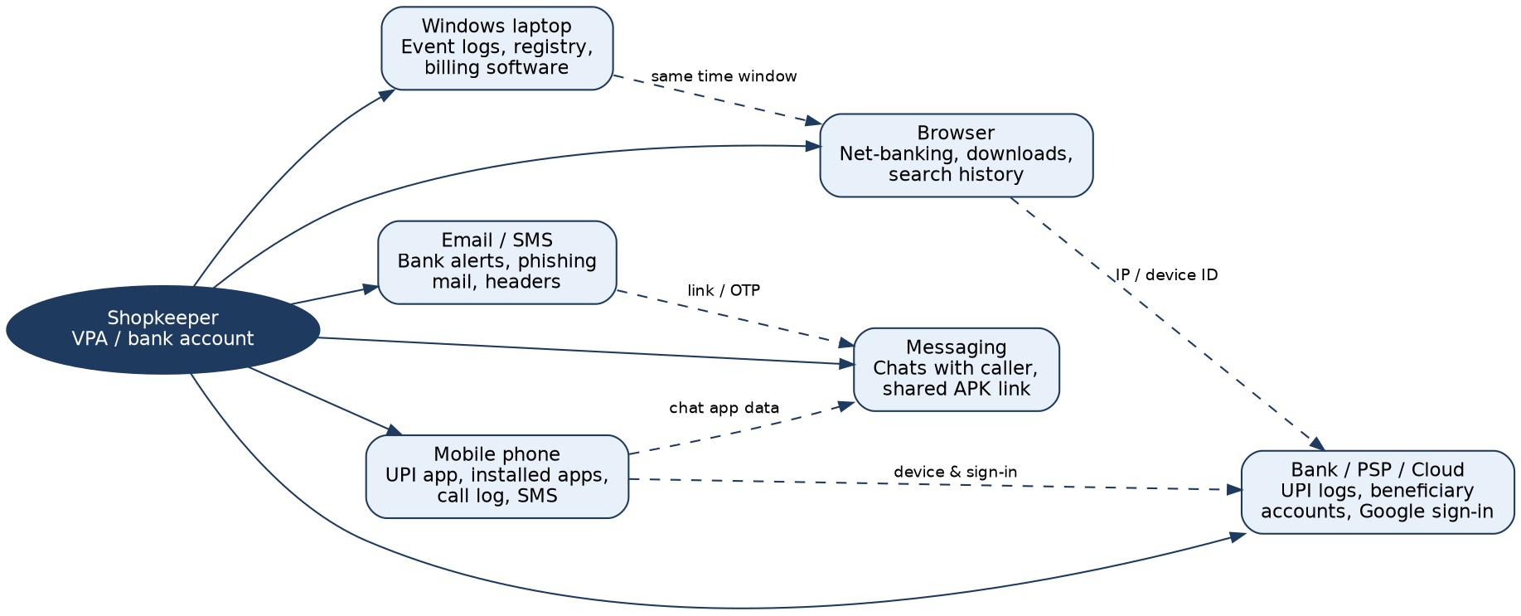
Figure 5: Multi-source evidence map. Solid lines link each source to the shopkeeper; dashed lines show correlations between sources
No. | Hypothetical artefact | Source | Time (IST) | Links to
1 | Incoming call of 14 min from an unknown mobile number | Phone call log / telecom record | 08-Oct 20:41 | Artefacts 2 and 3
2 | WhatsApp message with a link to "KYC_Update.apk"; file installed from unknown sources | Messaging app + phone package data | 08-Oct 20:49 to 20:55 | Artefact 1
3 | Remote-control app granted accessibility permission and screen-sharing started | Phone settings and app data | 08-Oct 20:58 | Artefact 2
4 | Windows logon active and billing software open, laptop idle, no remote-tool launch | Laptop event log | 10-Oct 14:00 to 16:30 | Gap: laptop not linked to requests
5 | Collect requests created from the merchant VPA, device ID of the shop phone, IP from a mobile data network | Bank / PSP log | 10 to 12 Oct, late night | Artefact 3 (phone controlled remotely)
6 | Bank alert email: new device registered for the account | Email | 08-Oct 21:02 | Artefacts 2, 3
7 | Credits moved to two other accounts within minutes of approvals | Bank records of mule accounts | 10 to 12 Oct | Artefact 5
Q37. Major challenges in digital forensics with distributed evidence
- Volume and variety. Many devices, apps and data formats make collection and review slow and costly.
- Encryption. Locked phones, device encryption and end-to-end encrypted chats can block access to content.
- Jurisdiction and third-party access. Banks, telecom operators and cloud providers hold key evidence, and it may sit in other regions or require formal legal requests.
- Volatility and retention. Logs and cloud records are deleted after fixed periods, messages may auto-delete, and delay in requests causes loss.
- Time synchronisation. Devices and services use different clocks and time zones, making correlation error-prone.
- Attribution. Linking an account, device or IP to a person is hard when remote-control apps, VPNs, shared devices or stolen credentials are involved.
- Anti-forensics. Deletion tools, private browsing, timestamp changes and fake identities in mule accounts hide traces.
- Privacy and legality. Personal data of the shopkeeper, customers and third parties must be protected, and collection must follow lawful authority.
- Chain of custody and authentication. Records received from providers and remote systems must still be shown to be genuine and unaltered.
- Tool and OS change. Frequent app and OS updates outpace forensic tool support, so findings need validation.
Q38. Final investigation conclusion
Category | Findings
Direct evidence | The bank and PSP logs show the collect requests were created from the shop's merchant VPA, with device ID and IP for each. The phone package data shows a side-loaded remote-control app installed on 8 October. The mule-account records show where the money went.
Corroborating evidence | The call log and the WhatsApp message with the APK link (artefacts 1 and 2); the bank's new-device alert (6); a laptop with no sign of the requests being sent from it (4); credits moving to other accounts within minutes (7). Together these support the shopkeeper's account that his phone was controlled by someone else.
Unresolved questions | Who owns the mule accounts and the calling number (needs bank and telecom records)? Was any payment approved by the shopkeeper himself? Did he share an OTP willingly? Does any device-ID or IP match a location he controlled? Were other devices involved? Were the requests sent by one person or a network?

Overall assessment. The evidence is more consistent with a remote takeover of the shopkeeper's phone than with the shopkeeper sending the requests himself, but this is a conclusion of probability, not certainty. Recommended actions: send preservation requests to the banks and operators, freeze the receiving accounts through the proper channel, remove the remote app and change credentials, and interview the shopkeeper again about the call and any OTPs shared. The report should state these limits clearly and not name an offender until the unresolved points are answered.
Deliverables: multi-source evidence map (Figure 5); correlation matrix (Q36); challenge analysis (Q37); final investigative summary (Q38).

